PONDICHERRY UNIVERSITY
(A Central university)



SCHOOL OF ENGINEERING AND TECHNOLOGY DEPARTMENT OF COMPUTER SCIENCE
M.Sc. Computer Science

NAME : MUHAMMAD MUSHARAF M

REG. NO. : 23370037

SEMESTER : II - Semester

SUBJECT : CSSC 424 – DATABASE SYSTEM LAB

PONDICHERRY UNIVERSITY
(A Central university)



SCHOOL OF ENGINEERING AND TECHNOLOGY
DEPARTMENT OF COMPUTER SCIENCE
M.Sc. Computer Science PRACTICAL LAB RECORD
BONAFIDE CERTIFICATE
This is to certify that this is a Bonafide record of practical work done by MUHAMMAD MUSHARAF M, having Reg. No. 23370037 semester - II from the month February 2024 to June 2024.

FACULTY IN-CHARGE

SUBMITTED FOR THE PRACTICAL EXAM HELD ON:

INTERNAL EXAMINER EXTERNAL EXAMINER
INDEX

____________________________________________________________________________________________

EX.  No | DATE | TITLE | PAGE | SIGNATURE
1 |  | Experiment 1 | 4
2 |  | Experiment 2 | 13
3 |  | Experiment 3 | 15
4 |  | Experiment 4 | 17
5 |  | Experiment 5 | 22
6 |  | Experiment 6 | 25
7 |  | Experiment 7 | 28
8 |  | Experiment 8 | 31
9 |  | Experiment 9 | 35
10 |  | Experiment 10 | 39
11 |  | Experiment 11 | 49

Experiment 1
SQL Practice 1
create database vamsi;
use vamsi;
create table salesman(salesman_id int primary key,name varchar(30),city varchar(30),commission float);
insert into salesman (salesman_id,name,city,commission)
values(5001,"James Hoog","New York",0.15),
(5002,"Nail Knite","Paris",0.13),
(5005,"Pit Alex","London",0.11),
(5006,"MC Lyon","Paris",0.14),
(5003,"Lauson Hen",null,0.12),
(5007,"Paul Adam","Rome",0.13);

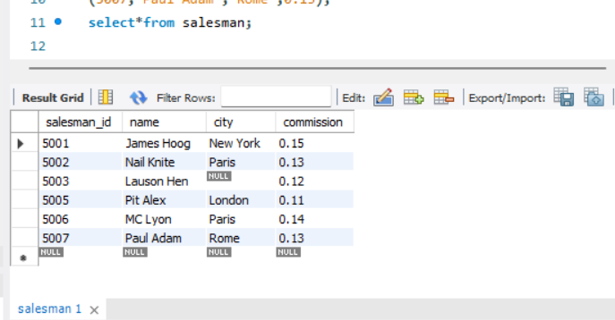

create table customer(customer_id int,customer_name varchar(30),city varchar(30),grade int,salesman_id int,
primary key (customer_id),foreign key (salesman_id) references salesman (salesman_id));
insert into customer1(customer_id,customer_name,city,grade,salesman_id)
values(3002,"Nick Rimando","New York",100,5001),
(3005,"Graham Zusi","California",200,5002),
(3001,"Brad Guzan","London",null,null),
(3004,"Fabian Johns","Paris",300,5006),
(3007,"Brad Davis","New York",200,5001),
(3009,"Geoff Camero","Berlin",100,null),
(3008,"Julian Green","London",300,5002),
(3003,"Jozy Altidor","Mancow",200,5007);
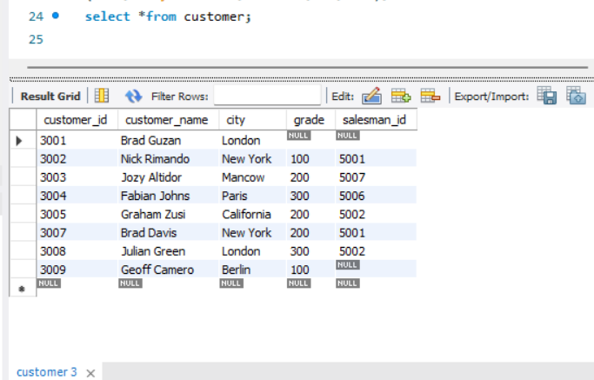

create table order1(order_no int,purch_amt float,order_date date,customer_id int,salesman_id int);
insert into order1(order_no,purch_amt,order_date,customer_id,salesman_id)
values(70001,150.5,"2016-10-05",3005,5002),
(70009,270.5,"2016-09-10",3001,null),
(70002,65.5,"2016-10-05",3002,5001),
(70004,110.5,"2016-08-17",3009,null),
(7007,948.5,"2016-09-10",3005,5002),
(70005,2400.6,"2016-07-27",3007,5001),
(70008,5760,"2016-09-10",3002,5001),
(70010,19830.43,"2016-10-10",3004,5006),
(70003,2480,"2016-10-10",3009,null);

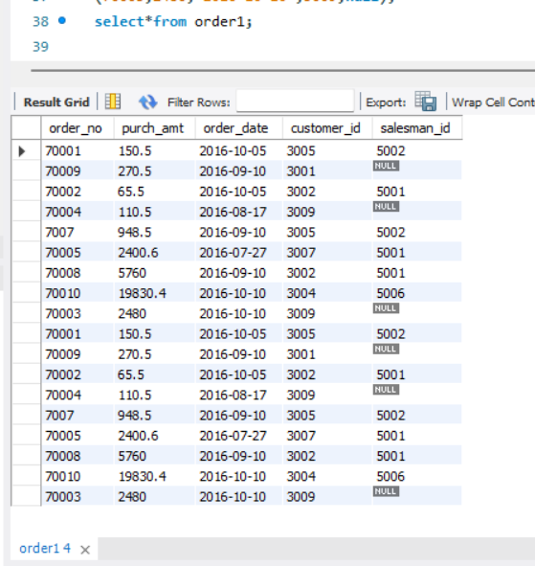
Query 1
• Display name and commission of all the salesmen.
select name,commission from salesman;
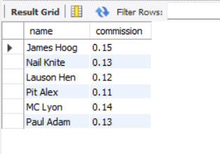

Query 2
• Retrieve salesman id of all salesmen from orders table without any repeats.
select distinct salesman_id from order1;
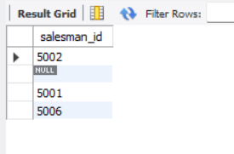

Query 3
• Display names and city of salesman, who belongs to the city of Paris.
select name,city from salesman where city="paris";
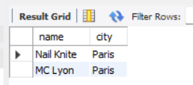

Query 4
• Display all the information for those customers with a grade of 200.
select * from customer where grade=200;
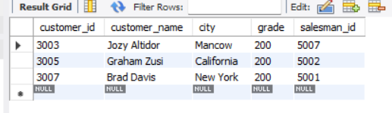

Query 5
• Display the order number, order date and the purchase amount for order(s) which will be delivered by the salesman with ID 5001.
select order_no,order_date,purch_amt from order1 where salesman_id=5001;
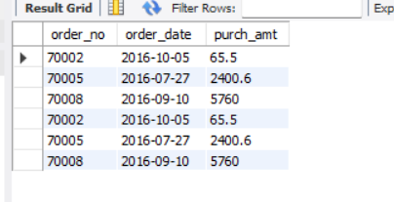

Query 6 (table: customer)
• Display all the customers, who are either belongs to the city New York or not had a grade above 100.
select*from customer where city='New York' or not grade>100;
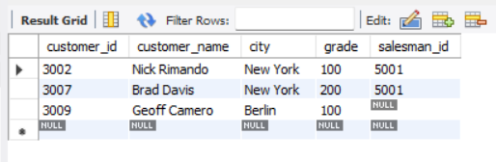
Query 7 (table: salesman)
• Find those salesmen with all information who gets the commission within a range of 0.12 and 0.14.
select*from salesman where (0.12<commission>0.14);
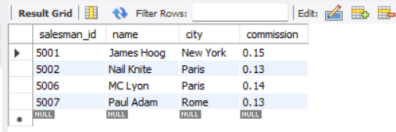
select*from salesman where(commission between 0.12 and 0.14);
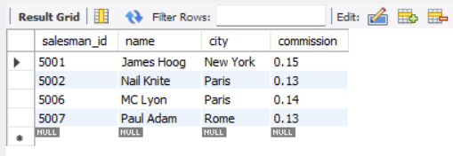

Query 8 (table: customer)
• Find all those customers with all information whose names are ending with the letter 'n'.
select*from customer where customer_name like '%n';
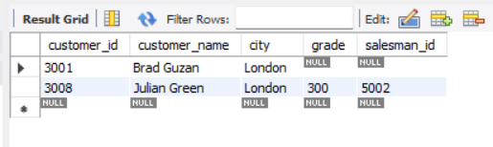

Query 9 (table: salesmen)
• Find those salesmen with all information whose name containing the 1st character is 'N' and the 4th character is 'l' and rests may be any character.
select*from salesman where name like 'n__l%';
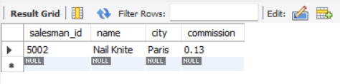

Query 10 (table: customer)
• Find that customer with all information who does not get any grade except NULL.
select*from customer where grade is Null;
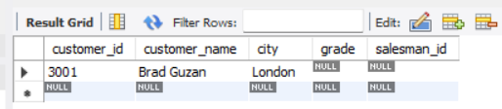

Query 11 (table: orders)
• Find the total purchase amount of all orders.
select sum(purch_amt) from order1;
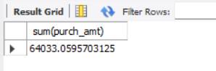

Query 12 (table: orders)
• Find the number of salesman currently listing for all of their customers.
select count(salesman_id) from customer;
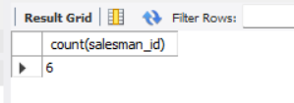
select count(distinct salesman_id) from order1;
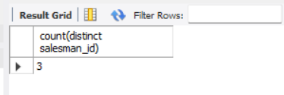

Query 13 (table: customer)
• Find the highest grade for each of the cities of the customers.
select city,max(grade) from customer group by city;
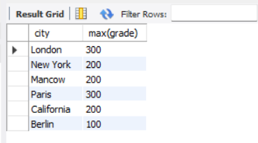

Query 14 (table: orders)
• Find the highest purchase amount ordered by the each customer
with their ID and highest purchase amount.
select customer_id,max(purch_amt) from order1 group by customer_id;
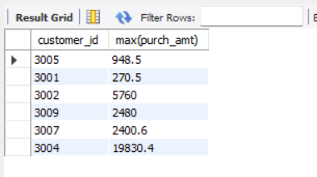

Query 15 (table: orders)
• Find the highest purchase amount ordered by the each customer on a particular date with their ID, order date and highest purchase amount.
select customer_id, order_date, max(purch_amt) from order1
group by customer_id, order_date;
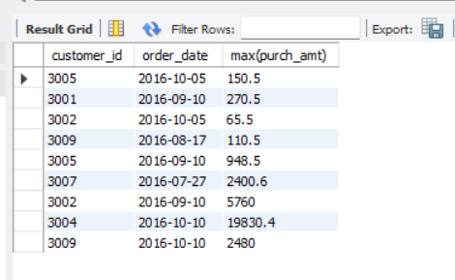

Query 16 (table: orders)
• Find the highest purchase amount on a date '2012-08-17' for each salesman with their ID.
select salesman_id, max(purch_amt) from order1
where order_date = '2012-08-17' group by salesman_id;
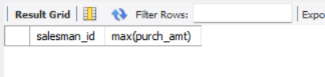
Query 17 (table: orders)
• Find the highest purchase amount with their customer ID and order date, for only those customers who have the highest purchase amount in a day is more than 2000.
select customer_id, order_date, MAX(purch_amt) from order1
group by customer_id, order_date having max(purch_amt) > 2000.00;
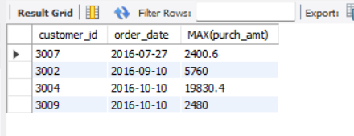

Query 18 (table: orders)
• Write a SQL statement that counts all orders for a date August 17th, 2012.
select count(*) from order1 where order_date = '2012-08-17';
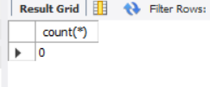
Experiment 2
TRIGGER:-
-- Source code
create database trigger1;
use trigger1;
-- Create student table
create table student(student_id integer null,name varchar(20),Address varchar(20),Marks integer(10));
-- Describe student table
desc student;

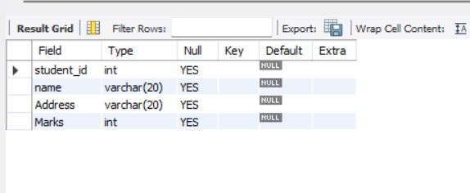
-- create trigger
create trigger student_trigger before insert on student for each row set new.Marks=new.Marks+100;
insert into student(student_id,name,Address,Marks) values('2','krishna','landon','90');
insert into student(student_id,name,Address,Marks) values('3','Ramu','India','70');

-- Display student table

select*from student;
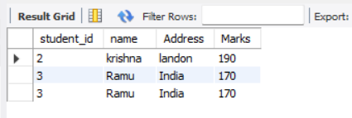
-- Display trigger

show triggers; 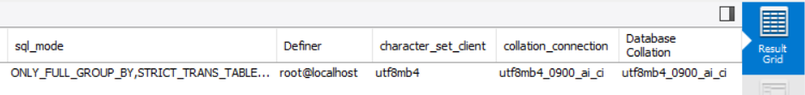

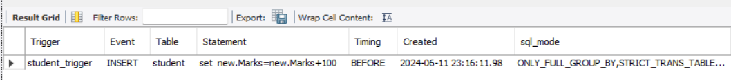

Experiment 3
PROCEDURES:-

create database procedures;
create table employees(emp_no integer primary key,e_name varchar(20),e_address varchar(20),e_ph_no varchar(20));
-- Insert table values
insert into employees values(101,'ramu','11-ut',2894833793);
insert into employees values(102,'vipin','43-c',6788299204);
insert into employees values(103,'sharon','41-or',7890489200);
insert into employees values(104,'max','21-e',9899204782);
-- Create procedures without parameters
DELIMITER $$
create procedure get_employees ()
begin
select*from employees;
end $$
DELIMITER ;
-- Call procedure
call get_employees();

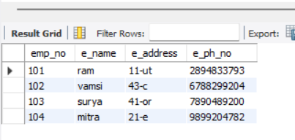
-- create procedures with parameters
DELIMITER $$
create procedure finds_employees (in id int)
begin
select*from employees ;
end $$
DELIMITER ;

call finds_employees(101);

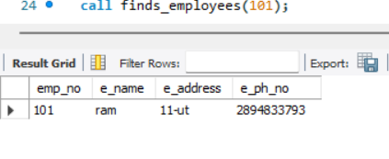

call finds_employees(104);

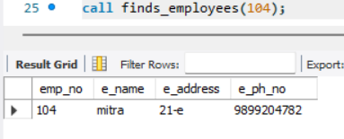

call finds_employees(102);

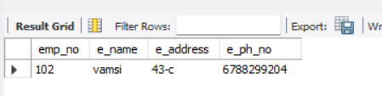
EXPERIMENT 4

1. Create the following Relation (Tables) with primary key integrity constraint
-- create
create table instructor(Id int primary key,name varchar(20),dept_name varchar(20),salary integer);
insert into instructor values('10101','Srinivasan','Comp.Sci.','65000'),
('12121','Wu','Finance','90000'),
('15151','Mozart','Music','40000'),
('22222','Einstein','Physics','95000'),
('32343','El Said','History','60000'),
('33456','Gold','Physics','87000'),
('45565','Katz','Comp.Sci.','75000'),
('58583','Califieri','History','62000'),
('76543','Singh','Finance','80000'),
('76766','Crick','Biology','72000'),
('83821','Brandt','Comp.Sci.','92000'),
('98345','Kim','Elec.Eng.','80000');
select*from instructor;
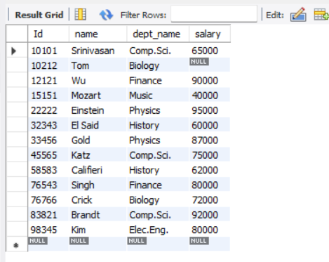

2. Create the following Relation (Tables) teaches
create table teaches(Id integer,Course_id varchar(20),sec_id integer,semester varchar(20),year integer);
insert into teaches values('10101','CS-101','1','Fall','2017'),
('10101','CS-315','1','Spring','2018'),
('10101','CS-347','1','Fall','2017'),
('12121','FIN-201','1','Spring','2018'),
('15151','MU-199','1','Spring','2018'),
('22222','PHY-101','1','Fall','2017'),
('32343','HIS-351','1','Spring','2018'),
('45565','CS-101','1','Spring','2018'),
('45565','CS-319','1','Spring','2018'),
('76766','BIO-319','1','Summer','2017'),
('76766','BIO-101','1','Summer','2018'),
('83821','CS-190','1','Spring','2017'),
('83821','CS-190','2','Spring','2017'),
('83821','CS-319','2','Spring','2018'),
('98345','EE-181','1','Spring','2017');

select*from teaches;
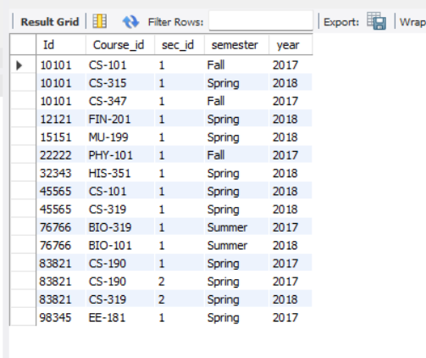

3. Insert following additional tuple in instructor ('10211', 'Smith', 'Biology', 66000)
insert into instructor value('10211','Smith','Biology','66000');

4. Delete this tuple from instructor ('10211', 'Smith', 'Biology', 66000)
delete from instructor where Id=10211;

5. Select tuples from instructor where dept_name = ‘History’
select*from instructor where dept_name='History';
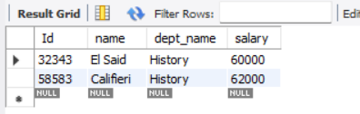

6. Find the Cartesian product instructor x teaches.
select*from instructor cross join teaches;
select *from instructor ,teaches;
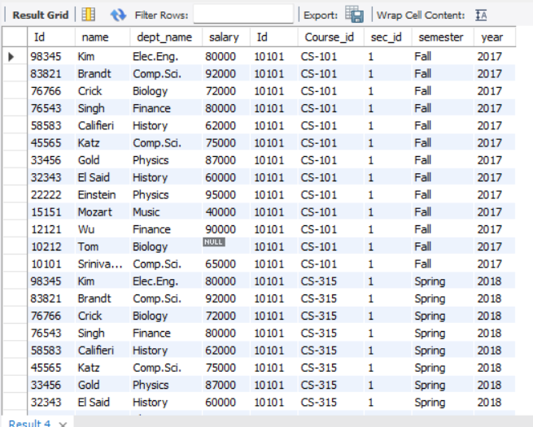
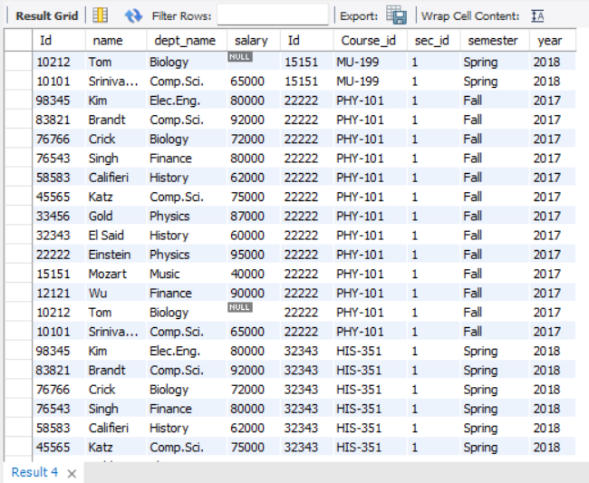

7. Find the names of all instructors who have taught some course and the course_id
select name, course_id from instructor, teaches where instructor.ID = teaches.ID;
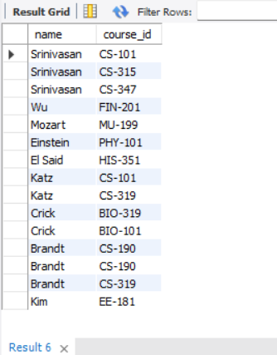

8. Find the names of all instructors whose name includes the substring “dar”.
select*from instructor where name like'%dar%';

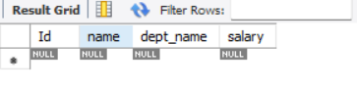

9. Find the names of all instructors with salary between 90,000 and 100,000 (that is, ≥ 90,000 and ≤ 100,000)
select name from instructor where (salary>=90000 and salary<=100000);
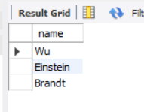
EXPERIMENT 5

1. Order the tuples in the instructors relation as per their salary.
select*from instructor order by salary;
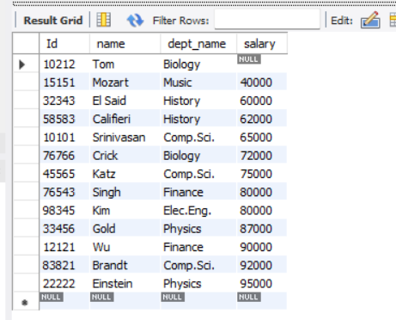

2. Find courses that ran in Fall 2017 or in Spring 2018
(select course_id from teaches where semester = 'Fall' and year = 2017)
union
(select course_id from teaches where semester = 'Spring' and year = 2018);
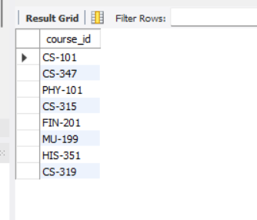

3. Find courses that ran in Fall 2017 and in Spring 2018
select course_id from teaches where (semester = 'Fall' and year = 2017) and (semester = 'Spring' and year = 2018);
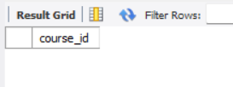

4. Find courses that ran in Fall 2017 but not in Spring 2018
select course_id from teaches where (semester = 'Fall' and year = 2017) and not (semester = 'Spring' and year = 2018);
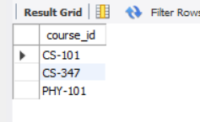

5. Insert following additional tuples in instructor :('10211', 'Smith', 'Biology', 66000), ('10212', 'Tom', 'Biology', NULL )
insert into instructor values('10211','Smith','Biology','66000'),
('10212','Tom','Biology',null);

6. Find all instructors whose salary is null.
select *from instructor where salary is null;
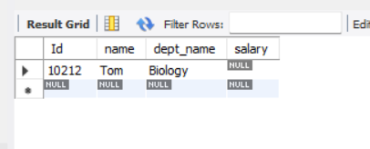

7. Find the average salary of instructors in the Computer Science department.
select avg(salary) from instructor where dept_name = 'Comp.Sci.';
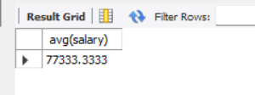

EXPERIMENT 6

1. Find the total number of instructors who teach a course in the Spring 2018 semester.
select count(distinct ID) from teaches where semester = 'Spring' and year = 2018;
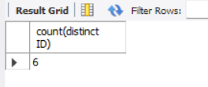

2. Find the number of tuples in the teaches relation
select count(*) from teaches;
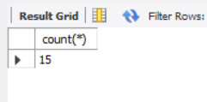

3. Find the average salary of instructors in each department.
select dept_name, avg(salary) as avg_salary from instructor group by dept_name;
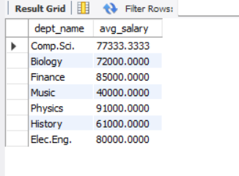
4. Find the names and average salaries of all departments whose average salary is greater than 42000
select dept_name, avg(salary) as avg_salary from instructor group by dept_name having avg(salary) > 42000;
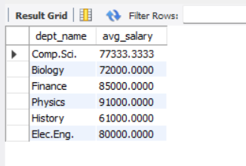

5. Name all instructors whose name is neither “Mozart” nor Einstein”
select distinct name from instructor where name not in ('Mozart', 'Einstein');
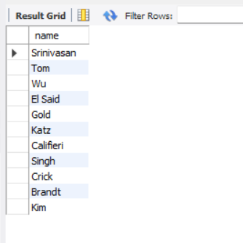

6. Find names of instructors with salary greater than that of some (at least one) instructor in the Biology department.
select name from instructor where salary > some (select salary from instructor where dept_name = 'Biology');
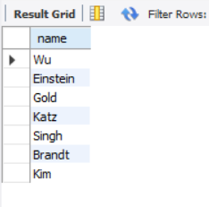

7. Find the names of all instructors whose salary is greater than the salary of all instructors in the Biology department.
select name from instructor where salary > all (select max(salary) from instructor where dept_name = 'Biology');
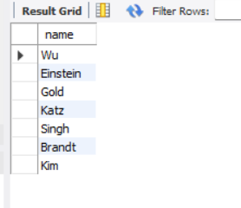

8. Find the average instructors’ salaries of those departments where the average salary is greater than 42,000
select dept_name, avg_salary from (select dept_name, avg(salary) from instructor group by dept_name) as dept_avg(dept_name, avg_salary) where avg_salary > 42000;
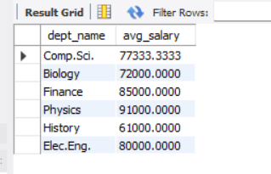
EXPERIMENT 7

1.Find all departments where the total salary is greater than the average of the total salary at all departments
select Dept_name from instructor group by Dept_name having sum(Salary) > (select avg(Salary) from instructor);
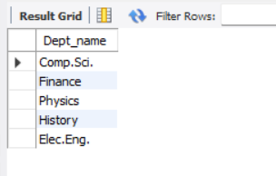

2.List the names of instructors along with the course ID of the courses that they taught
select instructor.name ,teaches.course_id from instructor join teaches on instructor.Id=teaches.Id;
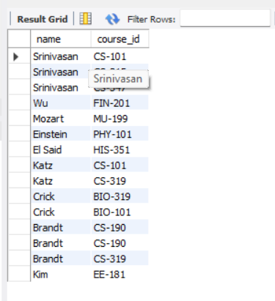

3.List the names of instructors along with the course ID of the courses that they taught. In case, an instructor teaches no courses keep the course ID as null.
select instructor.name ,teaches.course_id from instructor left join teaches on instructor.Id=teaches.Id;
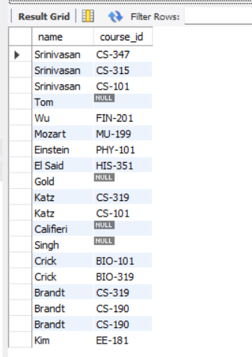

4.Create a view of instructors without their salary called faculty
create view faculty as select Id, name, dept_name from instructor;
select*from faculty;
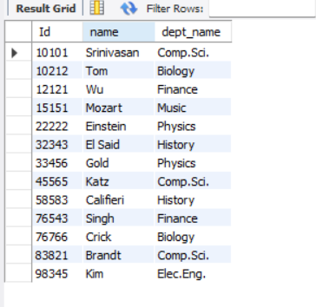

5.Give select privileges on the view faculty to the new user.
create user vamsi@localhost identified by 'vamsi3434';
grant select on faculty to vamsi@localhost;
show grants for vamsi@localhost;
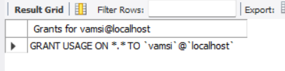

EXPERIMENT 8

1.Create a view of instructors without their salary called faculty
create view faculty as select Id, name, dept_name from instructor;
select*from faculty;

2.Create a view of department salary totals
create view department_salary_totals as select Dept_name, sum(Salary) as TotalSalary from instructor group BY Dept_name;
select*from department_salary_totals;
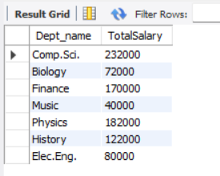

3.Create a role of student
create role 'student';

4.Give select privileges on the view faculty to the role student.
grant select on faculty to student;

5.Create a new user and assign her the role of student.

create user krishna@localhost identified by 'krishna3434';
show grants for krishna@localhost;
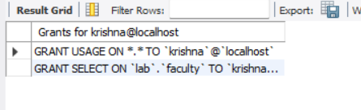

6.Login as this new user and find all instructors in the Biology department.
GRANT ALL PRIVILEGES ON student.* TO vamsi@localhost;
SELECT * FROM faculty WHERE dept_name = 'Biology';
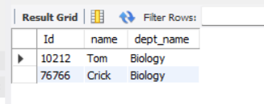

7.Revoke privileges of the new user
revoke select on faculty from 'vamsi'@'localhost';
show grants;
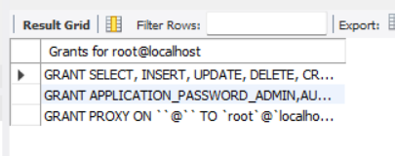

8.Remove the role of student.
drop role 'student';

9.Give select privileges on the view faculty to the new user.
GRANT SELECT ON faculty TO vamsi@localhost;

10.Login as this new user and find all instructors in the finance department.
SELECT * FROM faculty WHERE dept_name = 'Finance';
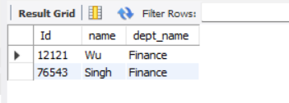

11.Login again as root user

12.Create table teaches2 with same columns as teaches but with additional constraint that that semester is one of fall, winter, spring or summer

CREATE TABLE teaches2 (
ID INT NOT NULL,
course_id VARCHAR(255) NOT NULL,
sec_id INT NOT NULL,
semester VARCHAR(255) NOT NULL CHECK (semester IN ('Fall', 'Winter', 'Spring', 'Summer')),
year INT NOT NULL,
FOREIGN KEY (ID) REFERENCES instructor(ID)
);

13.Create index ID column of teaches. Compare the difference in time to obtain query results with or without index.
CREATE INDEX idx_ID ON teaches (ID);

14.Drop the index to free up the space.
DROP INDEX idx_ID ON teaches;

EXPERIMENT 9

Accessing the database through Python
1. Insert following additional tuple in instructor : ('10211', 'Smith', 'Biology', 66000)
2. Delete this tuple from instructor : ('10211', 'Smith', 'Biology', 66000)
3. Select tuples from instructor where dept_name = ‘History’
4. Find the Cartesian product instructor x teaches.
5. Find the names of all instructors who have taught some course and the course_id
6. Find the names of all instructors whose name includes the substring “dar”.
7. Find the names of all instructors with salary between 90,000 and 100,000 (that is, ≥ 90,000 and ≤ 100,000)

SOURCE CODE:-
import mysql.connector

conn = mysql.connector.connect(
host='localhost',
user='root',
password='mysql@k2c89snw',
database='lab'
)

cursor = conn.cursor()

# 1
insert_query = """
INSERT INTO instructor (ID, name, dept_name, salary) VALUES
('10211', 'Smith', 'Biology', 66000)
"""
cursor.execute(insert_query)

# 2
tuple_to_delete = ('10211', 'Smith', 'Biology', 66000)

delete_query = "DELETE FROM instructor WHERE ID = %s AND name = %s AND dept_name = %s AND salary = %s"
cursor.execute(delete_query, tuple_to_delete)

# 3
dept_name = 'History'

select_query = "SELECT * FROM instructor WHERE dept_name = %s"
cursor.execute(select_query, (dept_name,))

results = cursor.fetchall()

for row in results:
print(row)

# 4
cartesian_query = """
SELECT * FROM instructor, teaches
"""

cursor.execute(cartesian_query)

results = cursor.fetchall()

for row in results:
print(row)

# 5
query = """
SELECT DISTINCT instructor.name, teaches.course_id
FROM instructor
JOIN teaches ON instructor.ID = teaches.ID
"""

# Execute the query
cursor.execute(query)

# Fetch the results
results = cursor.fetchall()

# Print the results
for row in results:
print(row)

# 6
query = """
SELECT name
FROM instructor
WHERE name LIKE '%dar%'
"""

cursor.execute(query)

results = cursor.fetchall()

for row in results:
print(row[0])

# 7
query = """
SELECT name
FROM instructor
WHERE salary BETWEEN 90000 AND 100000
"""

cursor.execute(query)

results = cursor.fetchall()

for row in results:
print(row[0])

conn.commit()

cursor.close()
conn.close()

OUTPUT:
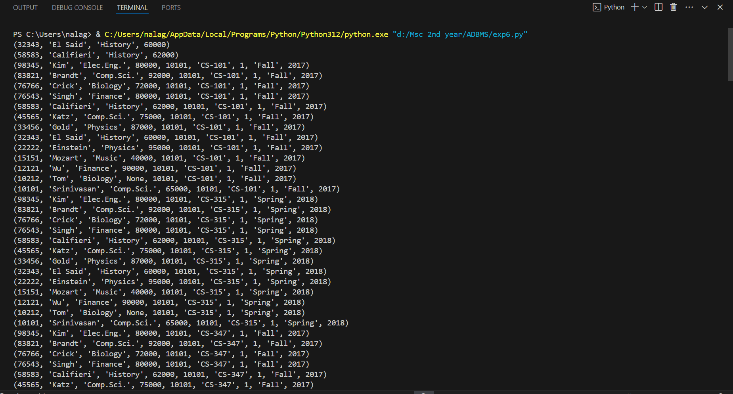

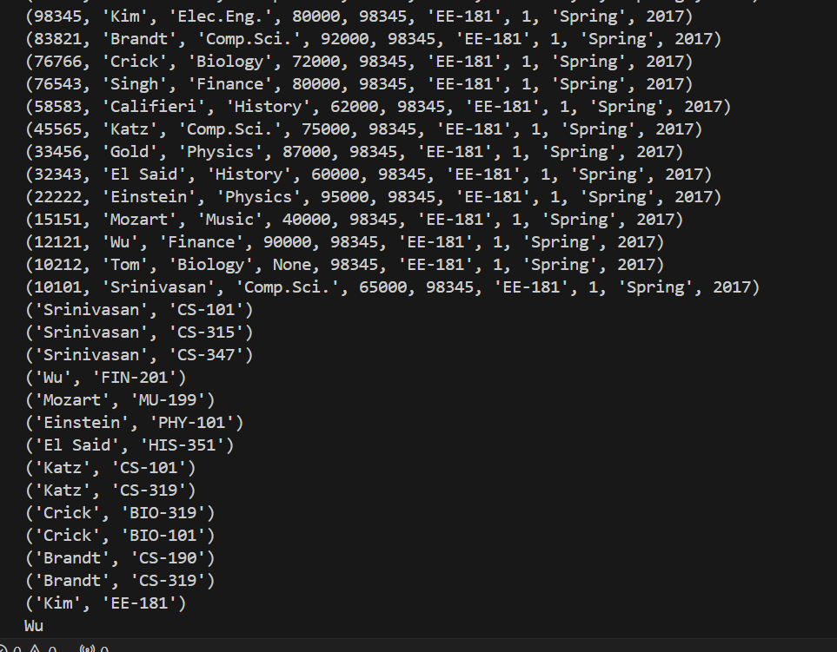
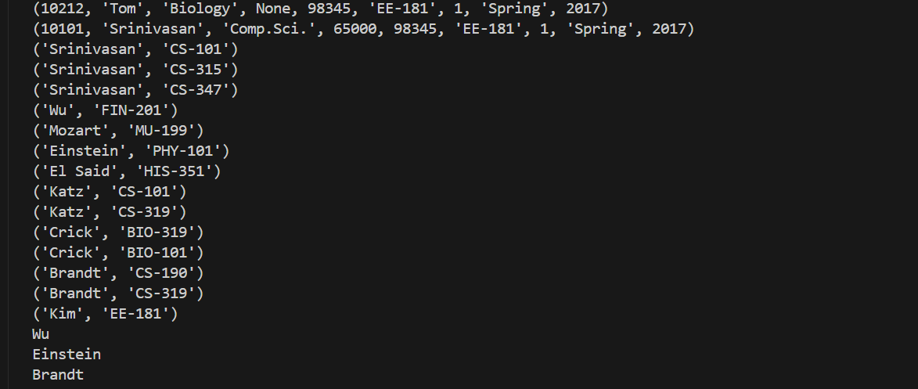

EXPERIMENT 10

1. Order the tuples in the instructors relation as per their salary.
2. Find courses that ran in Fall 2017 or in Spring 2018
3. Find courses that ran in Fall 2017 and in Spring 2018
4. Find courses that ran in Fall 2017 but not in Spring 2018
5. Insert following additional tuples in instructor ('10211', 'Smith', 'Biology', 66000) ('10212', 'Tom', 'Biology', NULL
6. Find all instructors whose salary is null.
7. Find the average salary of instructors in the Computer Science department.
8. Find the total number of instructors who teach a course in the Spring 2018 semester.
9. Find the number of tuples in the teaches relation
10. Find the average salary of instructors in each department
11. Find the names and average salaries of all departments whose average salary is greater than 42000
12. Name all instructors whose name is neither “Mozart” nor Einstein”.
13. Find names of instructors with salary greater than that of some (at least one) instructor in the Biology department.
14. Find the names of all instructors whose salary is greater than the salary of all instructors in the Biology department.
15. Find the average instructors’ salaries of those departments where the average salary is greater than 42,000.
16. Find all departments where the total salary is greater than the average of the total salary at all departments
17. List the names of instructors along with the course ID of the courses that they taught.
18. List the names of instructors along with the course ID of the courses that they taught. In case, an instructor teaches no courses keep the course ID as null.
SOURCE CODE:
import mysql.connector

conn = mysql.connector.connect(
host='localhost',
user='root',
password='mysql@k2c89snw',
database='lab'
)

cursor = conn.cursor()

# Order the tuples in the instructors relation as per their salary.
order_by_salary_query = """
SELECT * FROM instructor
ORDER BY salary
"""

cursor.execute(order_by_salary_query)

results = cursor.fetchall()

print("Question1:")
for row in results:
print(row)
print("\n")

# Find courses that ran in Fall 2017 or in Spring 2018
courses_in_spring_or_fall = """
SELECT DISTINCT course_id FROM teaches WHERE (semester='Fall'and year=2017)OR (semester='Spring' and year=2018)
"""

cursor.execute(courses_in_spring_or_fall)

results = cursor.fetchall()

print("Question2:")
for row in results:
print(row)
print("\n")

# Find courses that ran in Fall 2017 and in Spring 2018
courses_in_spring_and_fall = """
SELECT DISTINCT course_id FROM teaches WHERE (semester='Fall'and year=2017) AND (semester='Spring' and year=2018)
"""

cursor.execute(courses_in_spring_and_fall)

results = cursor.fetchall()

print("Question3:")
for row in results:
print(row)
print("\n")

# Find courses that ran in Fall 2017 but not in Spring 2018
course_in_fall_only = """
SELECT DISTINCT course_id FROM teaches t1 WHERE (t1.semester='Fall'and t1.year=2017) AND NOT EXISTS (SELECT 1 FROM teaches t2 WHERE t2.course_id= t1.course_id AND t2.semester='Spring' AND t2.year=2018)
"""

cursor.execute(course_in_fall_only)

results = cursor.fetchall()

print("Question4:")
for row in results:
print(row)
print("\n")

# Insert following additional tuples in instructor
insert_tuples= """
INSERT INTO instructor VALUES ('10211', 'Smith', 'Biology', 66000), ('10212',
'Tom', 'Biology', NULL )
"""
cursor.execute(insert_tuples)

select_table = """
SELECT * FROM instructor
"""

cursor.execute(select_table)

results = cursor.fetchall()

print("Question5:")
for row in results:
print(row)
print("\n")

# Find all instructors whose salary is null.
instructor_salary_null = """
SELECT name FROM instructor WHERE salary IS NULL
"""

cursor.execute(instructor_salary_null)

results = cursor.fetchall()

print("Question6:")
for row in results:
print(row)
print("\n")

# Find the average salary of instructors in the Computer Science department.
avg_cs_dept = """
SELECT AVG(salary) AS avg_salary FROM instructor WHERE dept_name='Comp. Sci.'
"""

cursor.execute(avg_cs_dept)

results = cursor.fetchall()

print("Question7:")
for row in results:
print(row)
print("\n")

# Find the total number of instructors who teach a course in the Spring 2018 semester.
instructors_spring = """
SELECT COUNT(DISTINCT ID) AS total_instructors FROM teaches WHERE semester='Spring' AND year=2018
"""

cursor.execute(instructors_spring)

results = cursor.fetchall()

print("Question8:")
for row in results:
print(row)
print("\n")

# Find the number of tuples in the teaches relation
teaches_count = """
SELECT COUNT(*) AS num_tuples FROM teaches
"""

cursor.execute(teaches_count)

results = cursor.fetchall()

print("Question9:")
for row in results:
print(row)
print("\n")

# Find the average salary of instructors in each department
avg_instructor = """
SELECT dept_name, AVG(salary) as avg_salary FROM instructor GROUP BY dept_name
"""

cursor.execute(avg_instructor)

results = cursor.fetchall()

print("Question10:")
for row in results:
print(row)
print("\n")

# Find the names and average salaries of all departments whose average salary is greater than 42000
avg_salary_greater = """
SELECT dept_name, AVG(salary) as avg_salary FROM instructor GROUP BY dept_name HAVING AVG(salary)>42000
"""

cursor.execute(avg_salary_greater)

results = cursor.fetchall()

print("Question11:")
for row in results:
print(row)
print("\n")

# Name all instructors whose name is neither “Mozart” nor Einstein”.
instructor_name = """
SELECT name FROM instructor WHERE name NOT IN ("Mozart","Einstein")
"""

cursor.execute(instructor_name)

results = cursor.fetchall()

print("Question12:")
for row in results:
print(row)
print("\n")

# Find names of instructors with salary greater than that of some (at least one) instructor in the Biology department.
salary_greater= """
SELECT l.name FROM instructor l WHERE l.salary > (SELECT salary FROM instructor WHERE dept_name='Biology' AND name="Crick")
"""

cursor.execute(salary_greater)

results = cursor.fetchall()

print("Question13:")
for row in results:
print(row)
print("\n")

# Find the names of all instructors whose salary is greater than the salary of all instructors in the Biology department.
salary_greater_biology = """
SELECT l.name FROM instructor l WHERE l.salary > (SELECT max(salary) FROM instructor WHERE dept_name='Biology')
"""

cursor.execute(salary_greater_biology)

results = cursor.fetchall()

print("Question14:")
for row in results:
print(row)
print("\n")

# Find the average instructors’ salaries of those departments where the average salary is greater than 42,000.
avg_instructor_greater = """
SELECT dept_name, AVG(salary) as average_salary FROM instructor GROUP BY dept_name HAVING AVG(salary)>42000
"""

cursor.execute(avg_instructor_greater)

results = cursor.fetchall()

print("Question15:")
for row in results:
print(row)
print("\n")

# Find all departments where the total salary is greater than the average of the total salary at all
department_salary = """
SELECT dept_name
FROM (
SELECT dept_name, SUM(salary) AS total_salary
FROM instructor
GROUP BY dept_name
) AS department_total_salary
WHERE total_salary > (
SELECT AVG(total_salary)
FROM (
SELECT SUM(salary) AS total_salary
FROM instructor
GROUP BY dept_name
) AS avg_total_salary
)
"""

cursor.execute(department_salary)

results = cursor.fetchall()

print("Question16:")
for row in results:
print(row)
print("\n")

# List the names of instructors along with the course ID of the courses that they taught
instructor_name_with_courseID = """
SELECT instructor.name, teaches.course_id
FROM instructor
JOIN teaches ON instructor.ID = teaches.ID
"""

cursor.execute(instructor_name_with_courseID)

results = cursor.fetchall()

print("Question17:")
for row in results:
print(row)
print("\n")

# List the names of instructors along with the course ID of the courses that they taught. In case, an instructor teaches no courses keep the course ID as null.
instructor_name_with_courseID_with_null = """
SELECT instructor.name, teaches.course_id
FROM instructor
LEFT JOIN teaches ON instructor.ID = teaches.ID
"""

cursor.execute(instructor_name_with_courseID_with_null)

results = cursor.fetchall()

print("Question18:")
for row in results:
print(row)
print("\n")

OUTPUT:-
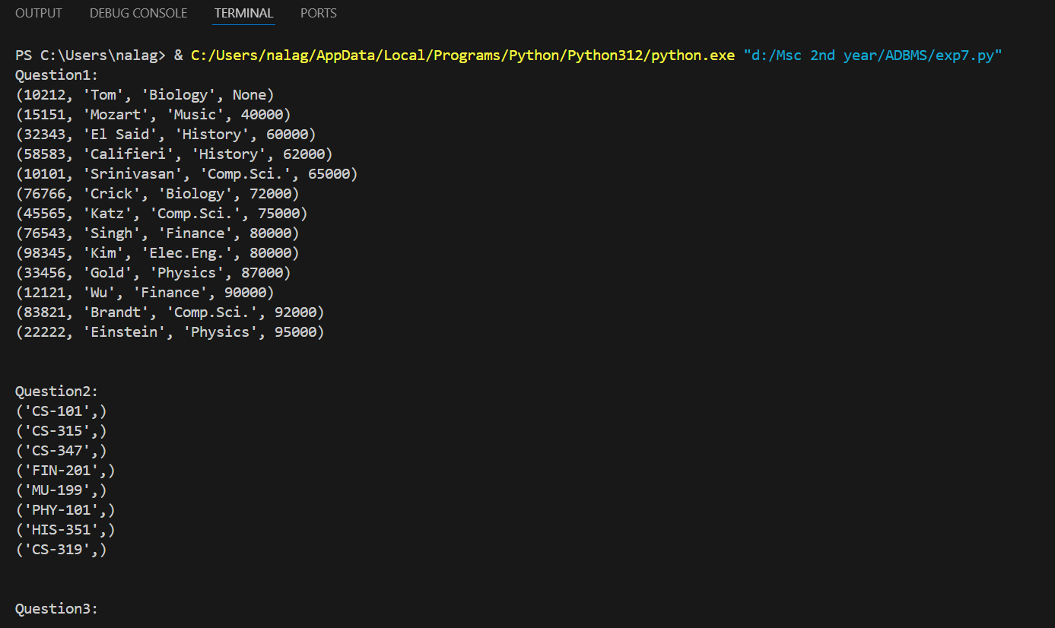

EXPERIMENT 11
OODBMS:

SQL*Plus: Release 21.0.0.0.0 - Production on Sat May 18 16:40:59 2024
Version 21.3.0.0.0

Copyright (c) 1982, 2021, Oracle. All rights reserved.

Enter user-name: system
Enter password:
Last Successful login time: Fri May 17 2024 11:33:55 +05:30

Connected to:
Oracle Database 21c Express Edition Release 21.0.0.0.0 - Production
Version 21.3.0.0.0

SQL> create type addr_ty as object
2 (street varchar(30),
3 city varchar(30),
4 state char(10),
5 zip varchar(10));
6 /

Type created.

SQL> create type person_ty as object
2 (name varchar(30),
3 address addr_ty);
4 /

Type created.

SQL> create type emp_ty as object
2 (empt_id varchar(10),person
3 person_ty);
4 /

Type created.

SQL> create table emp_oo
2 (full_emp emp_ty);

Table created.

SQL> insert into emp_oo values
2 (emp_ty('1001',
3 person_ty('Krishna',
4 addr_ty('1001 rt','Vijayawada','AP','52119'))));

1 row created.

SQL> insert into emp_oo values
2 (emp_ty('1002',
3 person_ty('Ajay',
4 addr_ty('182 ri','ppl','AP','52991'))));

1 row created.

SQL> insert into emp_oo values
2 (emp_ty('1003',
3 person_ty('Vamsi',
4 addr_ty('104 se','Kalapet','Pondy','14729'))));

1 row created.

SQL> select * from emp_oo;

FULL_EMP(EMPT_ID, PERSON(NAME, ADDRESS(STREET, CITY, STATE, ZIP)))
--------------------------------------------------------------------------------
EMP_TY('1001', PERSON_TY('Krishna', ADDR_TY('1001 rt', 'Vijayawada', 'AP
', '52119')))

EMP_TY('1002', PERSON_TY('Ajay', ADDR_TY('182 ri', 'ppl', 'AP ', '52991')
))

EMP_TY('1003', PERSON_TY('Vamsi', ADDR_TY('104 se', 'Kalapet', 'Pondy ', '14
729')))

SQL> desc emp_oo;
Name Null? Type
----------------------------------------- -------- ----------------------------
FULL_EMP EMP_TY

SQL> select * from emp_oo;

FULL_EMP(EMPT_ID, PERSON(NAME, ADDRESS(STREET, CITY, STATE, ZIP)))
--------------------------------------------------------------------------------
EMP_TY('1001', PERSON_TY('Krishna', ADDR_TY('1001 rt', 'Vijayawada', 'AP
', '52119')))

EMP_TY('1002', PERSON_TY('Ajay', ADDR_TY('182 ri', 'ppl', 'AP ', '52991')
))

EMP_TY('1003', PERSON_TY('Vamsi', ADDR_TY('104 se', 'Kalapet', 'Pondy ', '14
729')))

SQL> select e.full_emp.empt_id ID,
2 e.full_emp.person.name NAME,
3 e.full_emp.address.city CITY
4 from emp_oo e;
e.full_emp.address.city CITY
*
ERROR at line 3:
ORA-00904: "E"."FULL_EMP"."ADDRESS"."CITY": invalid identifier

SQL> select e.full_emp.empt_id ID,
2 e.full_emp.person.name NAME,
3 e.full_emp.address.city CITY from emp_oo e;
e.full_emp.address.city CITY from emp_oo e
*
ERROR at line 3:
ORA-00904: "E"."FULL_EMP"."ADDRESS"."CITY": invalid identifier

SQL> select e.full_emp.empt_id ID,
2 e.full_emp.person.name NAME,
3 e.full_emp.person.address.city CITY
4 from emp_oo e;

ID NAME CITY
---------- ------------------------------ ------------------------------
1001 Krishna Vijayawada
1002 Ajay ppl
1003 Vamsi Kalapet

SQL> update emp_oo e set
2 e.full_emp.person.name='Ramu'
3 where
4 e.full_emp.empt_id='1001';

1 row updated.

SQL> select e.full_emp.empt_id ID, e.full_emp.person.name NAME,
2 e.full_emp.person.address.city CITY
3 from emp_oo e;

ID NAME CITY
---------- ------------------------------ ------------------------------
1001 Ramu Vijayawada
1002 Ajay ppl
1003 Vamsi Kalapet

SQL> create or replace type newemp_ty as object(firstname varchar(20),
2 lastname varchar(20),birthdate date,
3 member function AGE(BirthDate in Date) return NUMBER)
4 /

Type created.

SQL> create or replace type body newemp_ty as
2 member function AGE(BirthDate in DATE) return NUMBER is
3 begin
4 RETURN ROUND(SysDate - BirthDate);
5 /

Warning: Type Body created with compilation errors.

SQL> drop type body;
drop type body
*
ERROR at line 1:
ORA-02302: invalid or missing type name

SQL> drop type body;
drop type body
*
ERROR at line 1:
ORA-02302: invalid or missing type name

SQL> create or replace type body newemp_ty as
2 member function AGE(BirthDate in DATE) return NUMBER is
3 begin
4 RETURN ROUND(SysDate - BirthDate);
5 /

Warning: Type Body created with compilation errors.

SQL> drop type body
2 ;

*
ERROR at line 2:
ORA-02302: invalid or missing type name

SQL> create or replace type body newemp_ty as
2 member function AGE(BirthDate in DATE) return NUMBER is
3 begin
4 RETURN ROUND(SysDate - BirthDate);
5 /

Warning: Type Body created with compilation errors.

SQL> create or replace type body newemp_ty as
2 member function AGE(BirthDate in DATE) return NUMBER is
3
4 begin
5 RETURN ROUND(SysDate - BirthDate);
6 /

Warning: Type Body created with compilation errors.

SQL> create or replace type body newemp_ty as
2 member function AGE(BirthDate in DATE) return NUMBER is
3 begin
4 RETURN ROUND(SysDate - BirthDate);
5 end;
6 end;
7 /

Type body created.

SQL> create table new_emp_oo
2 (employee newemp_ty);

Table created.

SQL> insert into new_emp_oo values
2 (newemp_ty('Ram','Lal','11-oct-1994'));

1 row created.

SQL> select e.employee.firstname,e.employee.age(e.employee.birthdate) from
2 new_emp_oo e;

EMPLOYEE.FIRSTNAME E.EMPLOYEE.AGE(E.EMPLOYEE.BIRTHDATE)
-------------------- ------------------------------------
Ram 10813

SQL> create table new_emp1 of emp_ty;

Table created.

SQL> create type emp_ty1 as object
2 (empt_id varchar(10),
3 person person_ty);
4 /

Type created.

SQL> create table emp_oo1
2 (full_emp emp_ty1);

Table created.

SQL> insert into new_emp1 values('1001',
2 person_ty('raj',addr_ty('143 tr','vizag',
3 'AP','35402')));

1 row created.

SQL> select * from new_emp1;

EMPT_ID
----------
PERSON(NAME, ADDRESS(STREET, CITY, STATE, ZIP))
--------------------------------------------------------------------------------
1001
PERSON_TY('raj', ADDR_TY('143 tr', 'vizag', 'AP ', '35402'))

SQL> select ref(p) from new_emp1 p;

REF(P)
--------------------------------------------------------------------------------
00002802092CBF85D6CCC64E378DB40C241BC48A1ECBF894A198384E17AEBAC6B87352B73C0041DC
E10000

SQL> drop type emp_ty1;
drop type emp_ty1
*
ERROR at line 1:
ORA-02303: cannot drop or replace a type with type or table dependents

SQL> create type new_dept_oo as object
2 (depno number(3),dname varchar(20));
3 /

Type created.

SQL> create table dept_table of new_dert_oo;
create table dept_table of new_dert_oo
*
ERROR at line 1:
ORA-00902: invalid datatype

SQL> create table dept_table of new_dept_oo;

Table created.

SQL> insert into dept_table values
2 (10,'com sci');

1 row created.

SQL> insert into dept_table values(12),'math');
insert into dept_table values(12),'math')
*
ERROR at line 1:
ORA-00933: SQL command not properly ended

SQL> insert into dept_table values(12,'math');

1 row created.

SQL> insert into dept_table values(13,'chem');

1 row created.

SQL> select ref(p) from dept_table p;

REF(P)
--------------------------------------------------------------------------------
000028020910F8CD3CD081404F94F75749C43250F11120502A851A457B8CB2C74EFB9CDFF60041DC
F90000

00002802098AB414E0B94F403CB9CEF071DFEB70EE1120502A851A457B8CB2C74EFB9CDFF60041DC
F90001

00002802092D6F9946325940C1A898749FD0ADF9831120502A851A457B8CB2C74EFB9CDFF60041DC
F90002

SQL> create table emp_test_fk
2 (empno number(3),
3 name varchar(20),
4 dept rwf new_dept_oo);
dept rwf new_dept_oo)
*
ERROR at line 4:
ORA-00907: missing right parenthesis

SQL> create table emp_test_fk
2 (empno number(3),
3 name varchar(20),
4 dept ref new_dept_oo);

Table created.

SQL> desc emp_test_fk
Name Null? Type
----------------------------------------- -------- ----------------------------
EMPNO NUMBER(3)
NAME VARCHAR2(20)
DEPT REF OF NEW_DEPT_OO

SQL> set desc depth 2
SQL> desc emp_test_fk
Name Null? Type
----------------------------------------- -------- ----------------------------
EMPNO NUMBER(3)
NAME VARCHAR2(20)
DEPT REF OF NEW_DEPT_OO
DEPNO NUMBER(3)
DNAME VARCHAR2(20)

SQL> insert into emp_test_fk
2 select 1001,'ram',ref(p) from dept_table p
3 where depno=10;
select 1001,'ram',ref(p) from dept_table p
*
ERROR at line 2:
ORA-01438: value larger than specified precision allowed for this column

SQL> insert into emp_test_fk
2 select 101,'ram',ref(p) from dept_table p
3 where depno=10;

1 row created.

SQL> insert into emp_test_fk
2 select 100,'surya',ref(p) from dept_table p
3 where depno=12;

1 row created.

SQL> insert into emp_test_fk
2 select 103,'sai',ref(p) from dept_table p
3 where depno=13'
4 ;
ERROR:
ORA-01756: quoted string not properly terminated

SQL> insert into emp_test_fk
2 select 103,'sai',ref(p) from dept_table p
3 where depno=13;

1 row created.

SQL> select * from emp_test_fk;

EMPNO NAME
---------- --------------------
DEPT
--------------------------------------------------------------------------------
101 ram
000022020810F8CD3CD081404F94F75749C43250F11120502A851A457B8CB2C74EFB9CDFF6

100 surya
00002202088AB414E0B94F403CB9CEF071DFEB70EE1120502A851A457B8CB2C74EFB9CDFF6

103 sai
00002202082D6F9946325940C1A898749FD0ADF9831120502A851A457B8CB2C74EFB9CDFF6

SQL> select empno,name,deref(e.dept) from emp_test_fk e;

EMPNO NAME
---------- --------------------
DEREF(E.DEPT)(DEPNO, DNAME)
--------------------------------------------------------------------------------
101 ram
NEW_DEPT_OO(10, 'com sci')

100 surya
NEW_DEPT_OO(12, 'math')

103 sai
NEW_DEPT_OO(13, 'chem')

SQL> select empno,name,deref(e.dept),deref(e.dept).depno depno,
2 deref(e.dept).dname dname from emp_fk e;
deref(e.dept).dname dname from emp_fk e
*
ERROR at line 2:
ORA-00942: table or view does not exist

SQL> select empno,name,deref(e.dept),deref(e.dept).depno depno,
2 deref(e.dept).dname dname from emp_test_fk e;

EMPNO NAME
---------- --------------------
DEREF(E.DEPT)(DEPNO, DNAME)
--------------------------------------------------------------------------------
DEPNO DNAME
---------- --------------------
101 ram
NEW_DEPT_OO(10, 'com sci')
10 com sci

100 surya
NEW_DEPT_OO(12, 'math')
12 math

EMPNO NAME
---------- --------------------
DEREF(E.DEPT)(DEPNO, DNAME)
--------------------------------------------------------------------------------
DEPNO DNAME
---------- --------------------

103 sai
NEW_DEPT_OO(13, 'chem')
13 chem

SQL> create table emp_table_fk
2 (employee emp_ty'
3 (employee emp_ty,/
4 ;
(employee emp_ty'
*
ERROR at line 2:
ORA-01756: quoted string not properly terminated

SQL> create table emp_table_fk
2 (employee emp_ty,
3 dept ref new_dept_oo);

Table created.

SQL> set describe depth 1
SQL> desc emp_table_fk
Name Null? Type
----------------------------------------- -------- ----------------------------
EMPLOYEE EMP_TY
DEPT REF OF NEW_DEPT_OO

SQL> set describe depth 2
SQL> desc emp_table_fk
Name Null? Type
----------------------------------------- -------- ----------------------------
EMPLOYEE EMP_TY
EMPT_ID VARCHAR2(10)
PERSON PERSON_TY
DEPT REF OF NEW_DEPT_OO
DEPNO NUMBER(3)
DNAME VARCHAR2(20)

SQL> set describe depth 3
SQL> desc emp_test_fk
Name Null? Type
----------------------------------------- -------- ----------------------------
EMPNO NUMBER(3)
NAME VARCHAR2(20)
DEPT REF OF NEW_DEPT_OO
DEPNO NUMBER(3)
DNAME VARCHAR2(20)

SQL> set describe depth 4
SQL> desc emp_test_fk
Name Null? Type
----------------------------------------- -------- ----------------------------
EMPNO NUMBER(3)
NAME VARCHAR2(20)
DEPT REF OF NEW_DEPT_OO
DEPNO NUMBER(3)
DNAME VARCHAR2(20)

SQL> insert into emp_table_fk values(
2 emp_ty(121,person_ty('ramu',addr_ty('123 re','pat','pb','37892')))),
3 ;
emp_ty(121,person_ty('ramu',addr_ty('123 re','pat','pb','37892')))),
*
ERROR at line 2:
ORA-00933: SQL command not properly ended

SQL> insert into emp_table_fk values(
2 emp_ty(121,person_ty('ramu',addr_ty('123 re','pat','pb','37892'))),
3 (select ref(p)
4 from dept_table p
5 where depno=10));

1 row created.

SQL> select * from emp_table_fk;

EMPLOYEE(EMPT_ID, PERSON(NAME, ADDRESS(STREET, CITY, STATE, ZIP)))
--------------------------------------------------------------------------------
DEPT
--------------------------------------------------------------------------------
EMP_TY('121', PERSON_TY('ramu', ADDR_TY('123 re', 'pat', 'pb ', '37892'))
)
000022020810F8CD3CD081404F94F75749C43250F11120502A851A457B8CB2C74EFB9CDFF6

SQL> select e.employee.empt_id id, e.employee.person.name name,
2 deref(e.dept),deref(e.dept).depno depno,
3 deref(e.dept).dname dname from emp_table_fk e;

ID NAME
---------- ------------------------------
DEREF(E.DEPT)(DEPNO, DNAME)
--------------------------------------------------------------------------------
DEPNO DNAME
---------- --------------------
121 ramu
NEW_DEPT_OO(10, 'com sci')
10 com sci

SQL>

